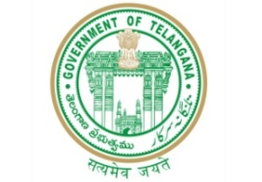**GOVERNMENT OF TELANGANA**

**TELANGANA TRIBAL WELFARE RESIDENTIAL DEGREE COLLEGE (GIRLS), MAHABUBABAD: MAHABUBABAD-DIST**

**https://www.ttwrdcs.ac.in/Mahabubabad**

**E-Mail Id:ttwrdcgirls.mahabubabad@gmail.com Cell No: 7901097695**

**Extension Lecture**

**Date : 03/10/2023**

**Venue : TTWRDC (G) - MHBD**

**Participants : 31**

**Department of statistics (UG) organized a guest lecture as a part of statistics course for II B.SC (MSCS) students on Friday 3rd October 2023. The session was on the topic "Correlation."**

**The guest speaker for the session was Dr. S. Ramesh Sir (Assistant professor) of commerce SR &BGNR College (A), Khammam.**

**Sir, delivered introduction of correlation, types, formulas and examples related to topic very effective manner ova students lean so many things i.e.; how we have to use correlation in real life situations.**

**Over all the session was completed smooth and effective manner.**

 